WEEK 7 ASSIGNMENT
Contents
WEEK 7: DATA STORAGE AND DATABASE INTERGRATION IN MOBILE APPLICATION 2
PRACTICAL ACTIVITIES UNDERTAKEN 2
TOOLS/SOFTWARE USED 2
PERSONNAL REFLECTION 2

WEEK 7: DATA STORAGE AND DATABASE INTERGRATION IN MOBILE APPLICATION
Develop a simple mobile application concept for managing student attendance.
The application should:
- Register students
- Store attendance records
- Generate attendance reports

PRACTICAL ACTIVITIES UNDERTAKEN

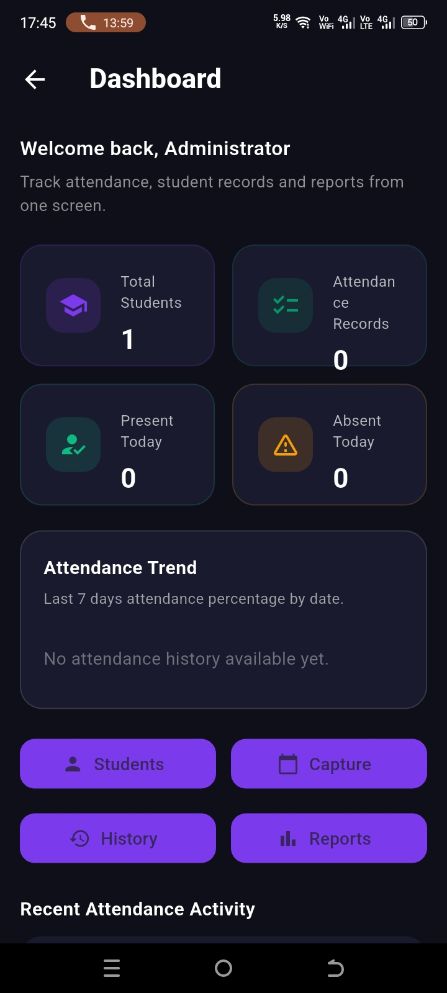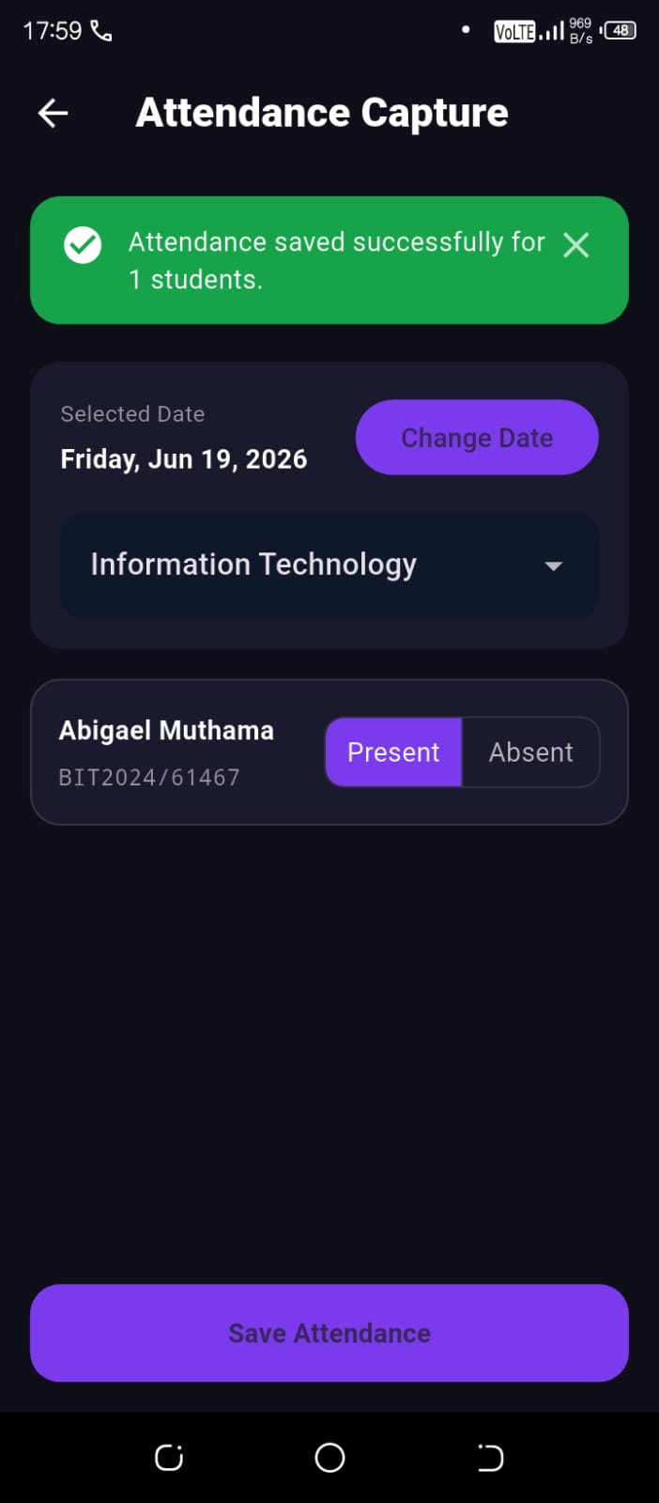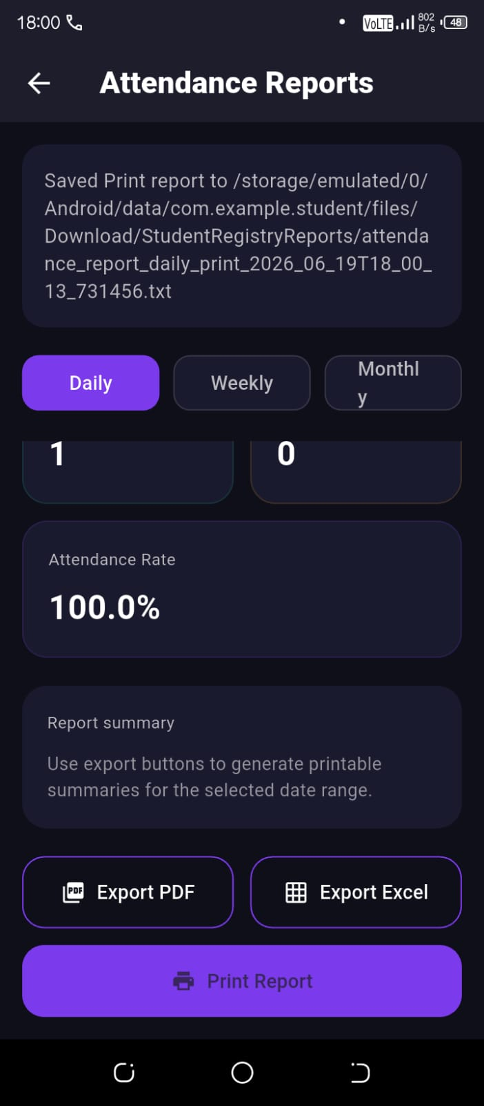

TOOLS/SOFTWARE USED
  - Flutter
  - VS code
  - Android studio

PERSONNAL REFLECTION
This task improved my understanding of local SQLite storage versus cloud Firestore syncing. I learned that local data is device-specific and must be migrated to Firebase for cross-device access. It strengthened my skills in data management, synchronization, and ensuring data persistence during system upgrades or reinstallation.

